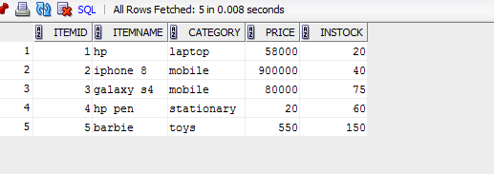

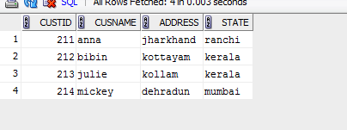

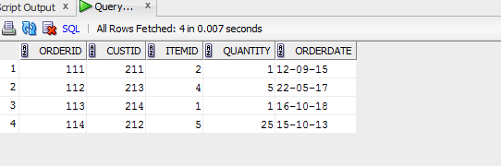

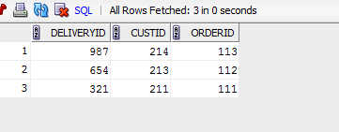

1

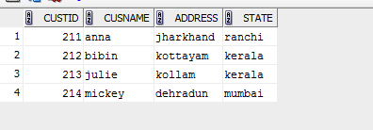

2

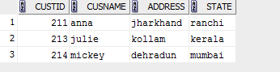

3 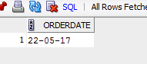

4



5



6

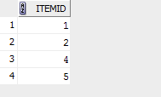

7

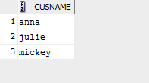

8

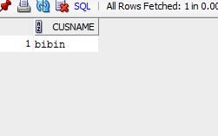

9



10

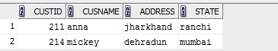

11

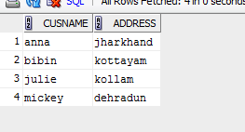

12 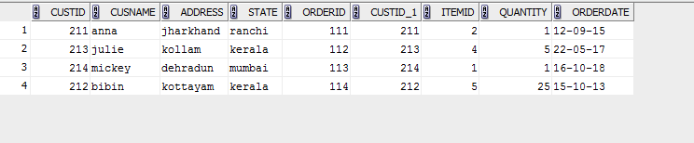

13

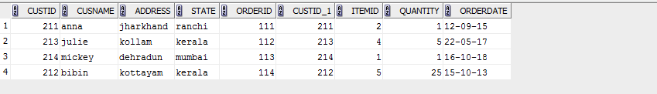

14 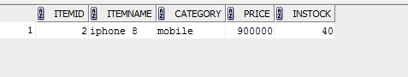

create table ite(itemid int primary key,itemname varchar(50),category varchar(20),price int,instock int check(instock>=0));

create table cus(custid int primary key, cusname varchar(20),address varchar(20),state varchar(20));

create table ors(orderid int primary key,custID int,itemid int not null,quantity int , orderdate date,constraint fk foreign key(itemid)references item(itemid));

create table dey(deliveryid int primary key,custID int, orderid int not null,constraint fk1 foreign key(custid) references customers(custid),constraint fk2 foreign key(orderid) references orders(orderid));

insert into ite values(2,'iphone 8','mobile', 900000,40);

insert into ite values(1,'hp','laptop',58000,20);

insert into ite values(4,'hp pen','stationary',20,60);

insert into ite values(3,'galaxy s4','mobile', 80000,75);

insert into ite values(5,'barbie','toys', 550,150);

select \* from ite;

insert into cus values(211,'anna','jharkhand','ranchi');

insert into cus values(212,'bibin','kottayam','kerala');

insert into cus values(213,'julie','kollam','kerala');

insert into cus values(214,'mickey','dehradun','mumbai');

select \* from cus;

insert into ors values(111,211,2,1,'12-09-2015');

insert into ors values(112,213,4,5,'22-05-2017');

insert into ors values(113,214,1,1,'16-10-2018');

insert into ors values(114,212,5,25,'15-10-2013');

select \* from ors;

insert into dey values(987,214,113);

insert into dey values(654,213,112);

insert into dey values(321,211,111);

select \* from dey;

select \* from cus where custid IN(select custid from ors);

select \* from cus where custid IN (select custid from dey);

select orderdate from ors where custid in (select custid from cus where cusname LIKE'j%');

select itemname, price from ite where itemid in (select itemid from ors where custID in(select custid from cus where cusname='mickey'));

select \* from cus where custid in (select custid from ors where orderdate >'31-01-2013'and orderid not in (select orderid from dey));

select itemid from ors union select itemid from ors where custid in (select custid from dey);

select cusname from cus where custid in (select custid from ors) intersect select cusname from cus where custid in (select custid from dey);

select cusname from cus where custid in (select custid from ors) minus select cusname from cus where custid in (select custid from dey);

select \* from cus where custid in (select custid from ors where quantity=(select max(quantity) from ors));

select \* from cus where custid in (select custid from ors where itemid in(select itemid from ite where price>5000 ));

select cusname, address from cus where custid not in (select custid from ors where itemid in (select itemid from ite where itemname='galaxy s4'));

select \* from cus left join ors on cus.custid=ors.custid;

select \* from cus order by state;

select \* from ite where price>(select avg(price) from ite ) order by category;